Expt no:3 Configure DNS and DHCP protocols using Packet Tracer
3.2 DNS protocol for translating domain names into IP addresses
Objective:
(ii) To configure and test the DNS protocol for translating domain names into IP addresses and enabling access to network resources using hostnames.
Software/Apparatus required:
(i) Cisco Packet Tracer
(ii) End Devices (PCs)
(iii) Switches
(iv) Copper Straight-through Cable / Automatic Cable Selector
(v) Routers
(vi) Server (DNS, HTTP and DHCP)
Procedure:
Objective 2: DNS protocol
1. Create the network topology using PCs, switches, a router, a DNS server, and a
web server.
2. Connect all devices using appropriate network cables.
3. Configure the router interfaces and enable communication between the networks.
4. Assign network addresses to all PCs, servers, and router interfaces.
5. Open the DNS server and enable the DNS service.
6. Create DNS records to map domain names to the web server.
7. Open the web server and enable the HTTP service.
8. Create and save the required web pages on the web server.
9. Configure the PCs with the DNS server address.
10. Open a web browser on any PC and access the website using the configured
domain name.
11. Verify that the webpage is displayed correctly and test connectivity using the
ping command.
12. Save the Packet Tracer project.
Diagram:
Objective 2: DNS protocol
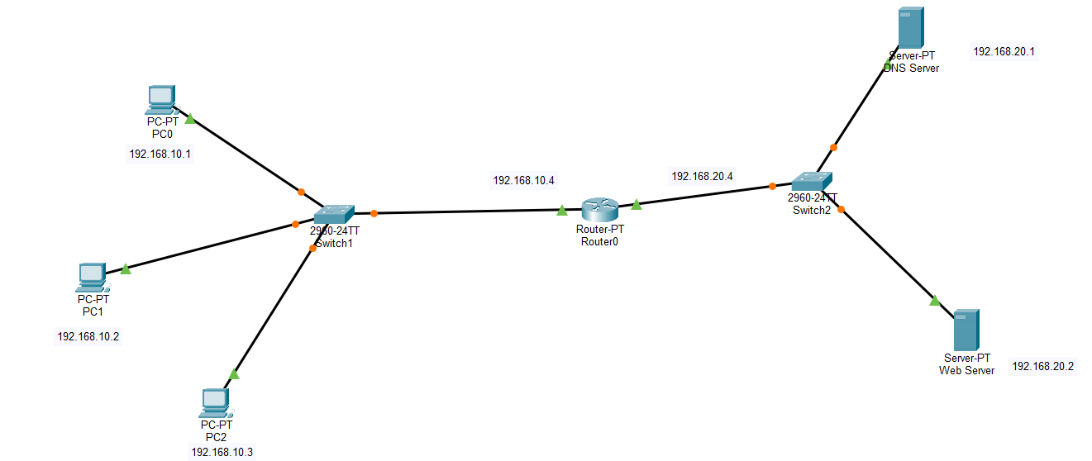

Output:

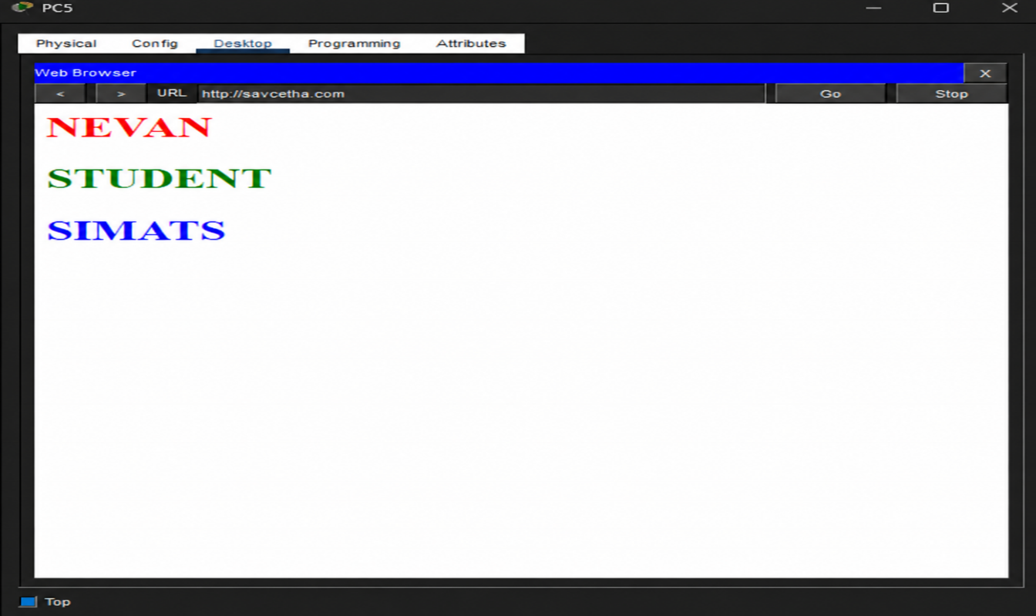

Result:
Objective 2: DNS Protocol
(ii) The DNS protocol was successfully configured, and the configured domain names were successfully resolved to access the web server using hostnames.

